Taipei Medical University
College of Nutrition
School of Nutrition and Health Sciences
Master Program New Students Handbook

April 2019

Content
I. Instructor Profile 3
II. Graduation Requirements for Master's Program 7
III. Courses and Credits 9
IV. List of Courses 9
V. Thesis Topic and Thesis Advisor Selection 10
VI. Master's Thesis Proposal and Examination 12
VII. University Regulations for Oral Defense (Degree Examination) 14
VIII. Department Graduation Procedure Application Form 22
IX. Graduation Procedure Application Form 23
X. Regulations for Direct Admission into Doctoral Program from Master's Program 25
XI. Scholarships, Lab Funds and Other Items 27
Attachment: Master's Thesis Format 28

I. Instructor Profile
University Telephone：(02)2736-1661 Department Fax:(02)2737-3112
Name | Title | Expertise and Research Domain | Contact
Hsieh Ming-Che | Emeritus Professor | Nutrition, nutrition and biochemistry, health food function evaluation, lipid and vitamin metabolism. | Campus Extension：6541  clark@tmu.edu.tw
Yeh Song-Ling | Emeritus Professor | Clinical nutrition, dietary therapy, nutrition for critical illness, nutritional assessment. | Campus Extension：None  sangling@tmu.edu.tw
Hsieh Rong-Hong | Professor and Department Director, Associate Dean of College of Nutrition | Molecular biology, nutritional immunology, mitochondrial medicine, biomedical patents. | Campus Extension：6557  hsiehrh@tmu.edu.tw
Chao Chen-Rui | Professor and Dean of College of Nutrition | Nutrition biochemistry, molecular and cell biology, nutritional physiology, biostatistics | Campus Extension：6548  chenjui@tmu.edu.tw
Chen Yu-Hwa | Professor and Director of School of Food Safety | Food and cancer, phytochemical bioactivity, nutritional toxicology, cell molecular biology. | Campus Extension：6550  yuehwa@tmu.edu.tw
Chen Jun-Rong | Professor (on temporary transfer) | Food chemistry, protein physiological activity, functional activity of food ingredients, chemical analysis. | Campus Extension：6551  syunei@tmu.edu.tw
Yang Hsu-Ching | Professor and Associate Dean of College of Nutrition | Alcoholic liver diseases, cell culture, nutritional physiology. | Campus Extension：6553  sokei@tmu.edu.tw
Huang Si-Chen | Professor and Director of Graduate Institute of Metabolism and Obesity Science | Vitamin biochemistry, fat chemistry, functional food research and development. | Campus Extension：6552  sihuang@tmu.edu.tw
Lin Shi-Hsiang | Professor (Graduate School Administrative Instructor) and Master's Program Director for the School of Food Safety | Food chemistry, organoleptic evaluation of food f, food processing, instrumental analysis. | Campus Extension：6555  lin5611@tmu.edu.tw
Yang Shu-Hui | Professor | Clinical nutrition, nutrition education and counseling, public health nutrition, lifecycle nutrition, diet design and management, vegetarian nutrition, kitchen science. | Campus Extension：6568  sherry@tmu.edu.tw
Chang Rong-Hsu | Professor (Administrative Instructor for international students) | Immune infection, enteral nutrition, endoplasmic reticulum stress transcription signal and cell death, intestinal T-cells. | Campus Extension：6542  susanchang@tmu.edu.tw
Hsia Shi-Min | Professor (Administrative Instructor for undergraduate school) | Reproductive endocrinology, functional foods, nutritional biochemistry, food technicians and nutritionist licensing. | Campus Extension：6558  bryanhsia@tmu.edu.tw
Yeh Chiu-Li | Professor | Clinical nutrition, nutrition biochemistry, nutritional immunology, cellular and molecular nutrition. | Campus Extension：6554  clyeh@tmu.edu.tw
Lan Shu-Chen | Associate Professor | Lifecycle nutrition (geriatric nutrition), HIV/AIDS nutrition, nutritional survey, diet and nutrition in dementia. | Campus Extension：6545  shuzan@tmu.edu.tw
Chen Yi-Jun | Associate Professor | Women and pediatric nutrition, public health nutrition, nutrition education, diet design and management. | Campus Extension：6559  yichun@tmu.edu.tw
Shi Chun-Guang | Associate Professor | Food hygiene and safety, food chemistry, diet and colorectal cancer, health food. | Campus Extension：6569  ckshih@tmu.edu.tw
Chiu Wan-Chun | Associate Professor | Dietary therapy, cell culture, nutrition in critical illness, diet design and management, nutritional counseling. | Campus Extension：6561  wanchun@tmu.edu.tw
Chien Yi-Wen | Associate Professor | Dietary therapy, nutrition biochemistry, nutrition, community nutrition. | Campus Extension：6556  ychien@tmu.edu.tw
Li Hsin-Chang | Associate Professor | Molecular nutrition, proteomics, vitamin nutrition, rare diseases. | Campus Extension：6560  sinchung@tmu.edu.tw
Chen Ya-lin | Assistant Professor | Liver diseases research and prevention. | Campus Extension：

Department Secretary (Ms. Chao Yu-Ying) | Campus Extension：6562  cyyheidi@tmu.edu.tw
Technician (Instructor Peng Hsiang-Chi) | Campus Extension：6546  hcpeng@tmu.edu.tw
College Manager (Ms. Tsai Hui-Ru) | Campus Extension：6538  tammy@tmu.edu.tw
College Secretary (Ms. Chang Hsin-Fang) | Campus Extension：6540  vivian0221@tmu.edu.tw
Secretary of Chinese Taipei Society for the Study of Obesity (Ms. Wang Yi-Ru) | Campus Extension：6565
653 Lab | Campus Extension：6563
654 Lab | Campus Extension：6564
655 Lab | Campus Extension：6549
656 Lab | Campus Extension：6566
657 Lab | Campus Extension：6567
408 Lab | Campus Extension：6505

II. Graduation Requirements for Master's Program

Graduation Requirements for Master's Program

Article 1 Duration of study: In accordance with University Regulations

Article 2 Credits required for graduation: Students are required to complete 32 credits or more (including 6 credits for graduation thesis). Credit requirements are as follow:
1. Required courses: 22 credits (including 6 credits for graduation thesis).
2. Elective courses: 10 credits (limited to 4 credits from other colleges; international students are exempt from this restriction).
3. Other regulations: Students from non-nutrition related departments or admitted to the Department's master's degree program on an equivalent examination, and for those who have not taken 4 credits of nutrition and 4 credits of nutritional therapy courses must make up with courses from the Department's undergraduate program (including at least 2 credits on nutrition and at least 2 credits on nutritional therapy or disease and nutrition, totaling 4 credits). Credits taken from the Department's undergraduate courses are not counted toward graduation credits.

Article 3 Article 3 Master's Thesis Proposal Examination:
1. Students applying for Degree Examination are required to submit a master's thesis proposal for review before the semester of graduation. Only those who pass the review may apply for Degree Examination.
2. Review method: Both oral and written reviews will be conducted by a committee convened by the Department. After the review, the review form and certificate of examination will be filed at the Department for reference.

Article 4 Master's Degree Examination:
1. Students must pass review by the Degree Examination Committee before applying for the Degree Examination. Submit the following documents to the Department:
(1) Proof of application for Degree Examination
(2) Official transcripts
(3) List of recommended Examination Committee members
(4) Thesis draft
(5) Two 2-inch photo in master's graduation cap (Write student number and name on the back).
(6) Applicant’s Name in English.
2. The thesis advisor will recommend 3-5 members for the master's Examination Committee. No more than one-third of the Committee members may be from outside the University.
The Department Chair will select from the list and appoint one to be the convenor. The thesis advisor and co-advisor shall not be the convenor.
3. After being approved by the Examination Committee, students shall revise their thesis according to the Committee’s feedback and then apply to the University for their Diploma.

III. Courses and Credits
Approved by the Department Affairs Meeting on July 13, 2010

1. The master's program courses in the School are generally taught by the Department's instructors. Full-time Department instructors have the duty and obligation to offer instruction. Experts or instructors from outside the University may be hired if necessary.
2. Required master's courses are offered every academic year. Elective courses are arranged according to need. Courses are negotiated by the Department Director and instructors, and approved by the Department Affairs Meetings.
3. Except for special research, 10 elective courses are offered each semester. In general, joint master's and doctoral electives are offered every other year when possible.
4. Discussion classrooms are available only to elective classes with at least 3 students. Electives not successfully offered for 2 consecutive years are closed for 1 year(time) according to recommendation, after which they may be offered again.
5. Students from departments other than the School of Nutrition and Health Sciences or related departments, or who are enrolled in the School's master's program based on equivalency examinations must take undergraduate courses at the School if they do not have 4 credits in nutrition and 4 credits in nutritional therapy (the undergraduate courses include at least 2 credits in nutrition and at least 2 credits in nutritional therapy or nutrition and diseases, totaling 4 credits). However, these Credits taken from undergraduate courses do not count towards graduation credits. Students are required to submit their university transcripts before the start of semester for administrative review and will be notified if they need to take additional courses to meet the program requirement.
6. Students with English proficiency below the Admissions Committee's minimum criteria at admission must take 2-4 credits of English courses to apply for Degree Examination.

IV. List of Courses
List of Courses for Master Program in School of Nutrition and Health Sciences in TMU
(Applicable to Newly-Admitted Students from 108 Academic Year: Click)

V. Thesis Topic and Thesis Advisor Selection

Thesis Topic and Thesis Advisor Selection
Revised and approved by the Department Affairs Meeting on August 11, 2009

1. Purpose
These principles for selecting thesis advisor are formulated to ensure that students successfully complete their research and are in balanced development.
2. Principles
Department instructors who are assistant professors or above have the responsibility, right and obligation to be master's thesis advisors. Students may only select instructors from the Department as their thesis advisor. To request an instructor from other department or university to co-advise with a full-time Department instructor, students must submit their request to the Department Director. The request must be approved by the Department Affairs Meeting.
3. Implementation
After registration, a forum will be held for new students and their instructors to facilitate understanding among new student and their instructors. After meeting with each professor, students will select their thesis advisor from the Department according to their preference. Students must submit their Thesis Advisor Consent Form to the administrative instructor before the start of the new semester.
4. Other Matters
To make changes after selecting their research lab and thesis advisor, students must obtain the consent of the original advisor and next advisor in accordance with the abovementioned principles. The change must be approved by the Department Director to proceed with advisor change. Each student is limited to one advisor change.

V. Thesis Topic and Thesis Advisor Selection--Attachment
School of Nutrition and Health Sciences Master's/ Doctoral Dissertation Advisor Consent Form

Student Number
Name
Current Address
Permanent Address
E-mail
Telephone | （Home) （Cell phone)
Thesis Topic (Provisional)
Signature of Thesis Advisor
Signature of Co-Advisor
Signature of Department Director |  | Signature of Administrative Instructor

I have read and agree to comply with the graduation regulations listed in the ___School of Nutrition and Health Sciences Handbook for Doctoral Program New Students Handbook. If I cannot meet the graduation requirements, I agree to postpone or relinquish my eligibility for dissertation review.

Signature of Graduate Student:

VI. Master's Thesis Proposal and Examination
1. Graduate students applying for Degree Examination are required to submit a master's thesis proposal for review one year before graduation. Only those who pass the review are eligible for the Degree Examination. The review will be in both oral and written forms, conducted by a committee of 3-5 members convened by the thesis advisor. After the review, a review feedback form will be filed in the Department.
2. In recent years, master's thesis proposal reviews are uniformly handled by the Department. Master's program students are divided into three groups. A review committee comprising full-time instructors from the Department will conduct the reviews. Review results will be filed with the Degree Committee for reference.
3. Review results are divided into four categories:
No. | Review Result | Measures
1 | Pass | None
2 | Minor Revision | Revise and submit to thesis advisor for review and approval.
3 | Major Revision | Review and submit to Review Committee for review and approval.
4 | Fail | Review and invite on and off- campus instructors to conduct a second thesis review.
4. Thesis format and related regulations are as follows:
(1) Content
1. Thesis content must be written in detail and paragraphed in thesis format. Sentences must be fluent, coherent and complete.
2. The content must be in the following order:
(i) Cover page (including the title in both Chinese and English, name of thesis advisor, student name and Student Number, and date of report)
(ii) Chinese abstract
(iii) Research motivation and purpose
(iv) Literature review
(v) Experimental design and method
(vi) Expected results
(vii) Conclusions
(viii) References
(2)Reference Format
1. In the thesis, include the author's last name in parentheses after the reference content. For two or less authors, state the authors' last names; for three or more authors, state the last name of the first author followed by "etc" (for Chinese literature) and "et al. "( for English literature), then the publication year of the literature, such as (Koo and Williams, 1981), (Harris et al., 1993). For different articles with the same references, differentiate the articles with an English letter after the publication year of the references.
2. Begin the reference section with Chinese references, followed by English references. Chinese references are ordered according to the increasing number of strokes in the author's last name. English references are alphabetically ordered according to the author's last name.
※Software are available for reference formatting. The library provides training for Endnote and Reference Manager software.

VII. University Regulations for Oral Defense (Degree Examination)
- Graduate students should apply for their Degree Examination before the deadline in mid-October ( the first semester) or late March (of the second semester). The exact dates are based on the University Calendar for the current academic year. (Please apply through the Degree Examination Operation System: Taipei Medical University Homepage-->Students-->Examinations--> Degree Examination Operation System). Submit application documents (as shown in the application form below) and two 2-inch photos in doctoral commencement cap to the Administrative Instruction Group (collected by the master's program class representative and submitted together).
- Have the following documents ready before the Degree Examination (please refer to the System for the latest version).
(i) Taipei Medical University Payment Receipt for Student Thesis Review Fee.
(ii) Taipei Medical University Graduate Thesis Certification
(iii) Taipei Medical University Original Confidentiality Agreement & Sign-in Form
(iv) Taipei Medical University / National Central Library Application Form for Delaying public Access to Thesis /Dissertations
- Oral defense must be completed by the schedule that Registration Group announce, After the Degree Examination, the graduate student must immediately submit the Taipei Medical University Payment Receipt for Student Thesis Review Fee to the Department Secretary's Office. Each graduate student may apply for a NT$400 meal reimbursement for the doctoral oral defense through the School of Nutrition and Health Sciences Master's and Doctoral Program Budget (Budget Code:108-6202-002-101). For details, please contact instructor Peng Hsiang-Chi.
- Submit the oral defense result to the administrative instructor: (1)Thesis(with Taipei Medical University Graduate Thesis Certification-copy, Taipei Medical University Degree Examination Confidentiality Agreement and Signature Form-copy, Taipei Medical University / National Central Library Application Form for Delaying public Access to Thesis /Dissertations-copy) (2)Grading form (3) Taipei Medical University Original Confidentiality Agreement & Sign-in Form (4) Taipei Medical University / National Central Library Application Form for Delaying public Access to Thesis /Dissertations, please follow the rules, you can check all rules at Graduate Degree Exam Application System.
- After documents have been confirmed and approved, program office will receive qualified list from Registration Section. Student may fill out graduation forms one work day after notification by program office. Diploma can be obtained after graduation forms are submitted. And please hand in the thesis with hardcover to program office.

- Obtain the doctoral and master’s dissertation e-file upload authorization from the National Digital Library of Theses and Dissertations in Taiwan website (http://ndltd.ncl.edu.tw/cgi-bin/gs32/gsweb.cgi/ccd=0xPR4x/webmge?Geticket=1), and submit an electronic copy of dissertation to the University Library website (http://cetd.tmu.edu.tw/etdsystem/submit/submitLogin) before February 15 (of the first semester) or August 15 (of the second semester).

[Note] The above dates are for reference only.
Exact dates will be based on University regulations for the current academic year.

VII. University Regulations for Oral Defense (Degree Examination) -- Attachment

臺北醫學大學學生論文審查費收據清冊
Taipei Medical University Payment Receipt for Student Thesis Review Fee
Please login the System for the latest version
系所學位學程承辦人填寫欄 製表日期： 年 月 日
單位名稱 |  |  |  |  |  | 學期 | 學年度 學期
序號 | 委員  姓名 | 學生  姓名 | 實領  金額 | 委員  簽章 | 戶籍住址  (區、里、鄰請務必填寫) |  |  | 身分證字號 | 代付人  (校內教職員工)
縣(市) 市區鄉鎮
村里 鄰 路(街)
段 巷 弄 號 樓之
縣(市) 市區鄉鎮
村里 鄰 路(街)
段 巷 弄 號 樓之
縣(市) 市區鄉鎮
村里 鄰 路(街)
段 巷 弄 號 樓之
縣(市) 市區鄉鎮
村里 鄰 路(街)
段 巷 弄 號 樓之
縣(市) 市區鄉鎮
村里 鄰 路(街)
段 巷 弄 號 樓之
縣(市) 市區鄉鎮
村里 鄰 路(街)
段 巷 弄 號 樓之
共計新台幣 萬 仟 佰 元整(金額請大寫，如：貳仟元整)
承辦人 |  |  |  |  | 主任／所長
注意事項：本表請併同「會2」單送出。

VII. University Regulations for Oral Defense (Degree Examination) -- Attachment
Taipei Medical University Graduate Thesis Certification
(A completed copy of this form must be bound in submitted thesis)
Please login the System for the latest version

____________________________________________________ (Title)

This thesis is the master’s degree thesis/doctoral dissertation of _________________________________ (Name) in the ____________________ (Department Name) at Taipei Medical University. This work has been judged satisfactory by the committee members after the degree candidate passed an oral examination.

Committee:

Thesis Advisor
(Name) (Institution, Title)

Thesis Co-Advisor
(Name) (Institution, Title)

Committee Member
(Name) (Institution, Title)

Committee Member
(Name) (Institution, Title)

Committee Member
(Name) (Institution, Title)

Committee Member
(Name) (Institution, Title)

YYYY, MM, DD

【SAMPLE】
VII. University Regulations for Oral Defense (Degree Examination) -- Attachment
Taipei Medical University Original Confidentiality Agreement & Sign-in Form
(This document should be bound with the dissertation)
Please login the System for the latest version
Degree Examination Basic Information
Dissertation Title | (Chinese)
 | (English)
Dissertation Advisor |  | Position
Student Name |  | School(Department), College
 |  | Student Number
Exam Time | ____(yy)____(mm)_____(dd)/ ________p.m.
Exam Venue
This Degree Examination involves the revealing or delivery of important intellectual property rights of the disclosing party, such as research and development results or confidential technology. The disclosing party has legal right to or expected interest in the confidential information, and only the following persons are authorized to participate. All participants understand and agree to protect the confidential content involved in this Examination and shall not use or in any way enable a third party to use the Confidential Information, or acquire any rights until the dissertation is disclosed to the public or until patent application has been completed.

Signature of the Degree Examination Committee Members:
Name | Unit | Position | Signature

Signature of Observers:
Name | Unit | Student Number  (or Instructor Position) | Signature

VII. University Regulations for Oral Defense (Degree Examination) -- Attachment
Taipei Medical University / National Central Library
Application Form for Delaying public Access to Thesis /Dissertations
(This form is required to be bound with the thesis)
Please login the System for the latest version
Applicant  (Please Print) |  |  | Graduation Date |  | (YYYY/MM)
Student ID |  |  | Degree |  | □Master’s  □Ph.D.
Department
Thesis/Dissertation Title
Options
□Immediate Public Access | Note: You might lose the right to apply for patent(s) for related research findings.
□Delay Public Access  Other than the bibliographic information, access to the table of contents, abstract, full-text and references of printed and electronic copy of the thesis / dissertation will be delayed. | Reasons for delaying:  □Apply for patent, (Patent application No. _________ )  □Prepare to submit an article to a journal based on my thesis / dissertation.
Delay until:

(YYYY/MM/DD)(maximum: 5 years)
Please tick the box after you read each statement clearly, otherwise, the application won't be accepted.
□After verifying the completion of this form, the library will stamp and upload the electronic copy of this thesis. The applicant must submit a printed copy of the thesis/dissertation (softcover) and degree exam documents to the program office. All related documents will then be transferred to the Office of Academic Affairs.
□If the applicant chooses to delay public access, please make sure the delay period on this form and the one on online system are consistent.
□In order to avoid any legal issue after the publication, please ensure that the thesis/dissertation doesn’t involve any copyright dispute or the unauthorized release of personal information.
Applicant:  (signature) |  | Seal of Department : |  | Seal of TMU Library :
Advisor:
(signature)
Director/Chair:
(signature)
Date of application: _______________________________________(YYYY/MM/DD)
*The Chinese version of this document shall prevail in case of any discrepancy or inconsistency between the Chinese version and its English translation
VII. University Regulations for Oral Defense (Degree Examination) -- Attachment
Instruction for Electronic Submission of Thesis
1. National Central Library - National Digital Library of Theses and Dissertations in Taiwan.
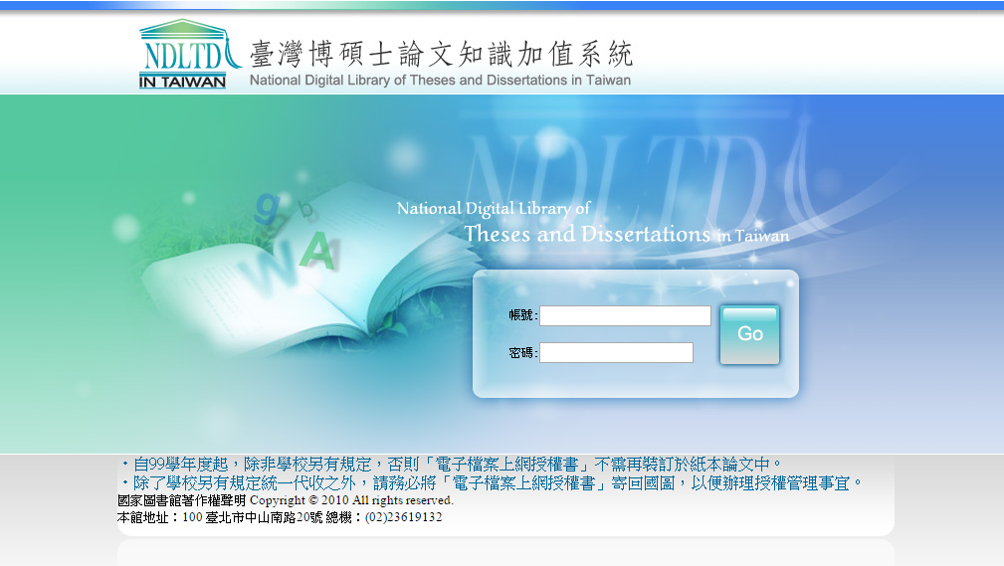

2. University Library--Taipei Medical University Electronic Theses & Dissertations Service
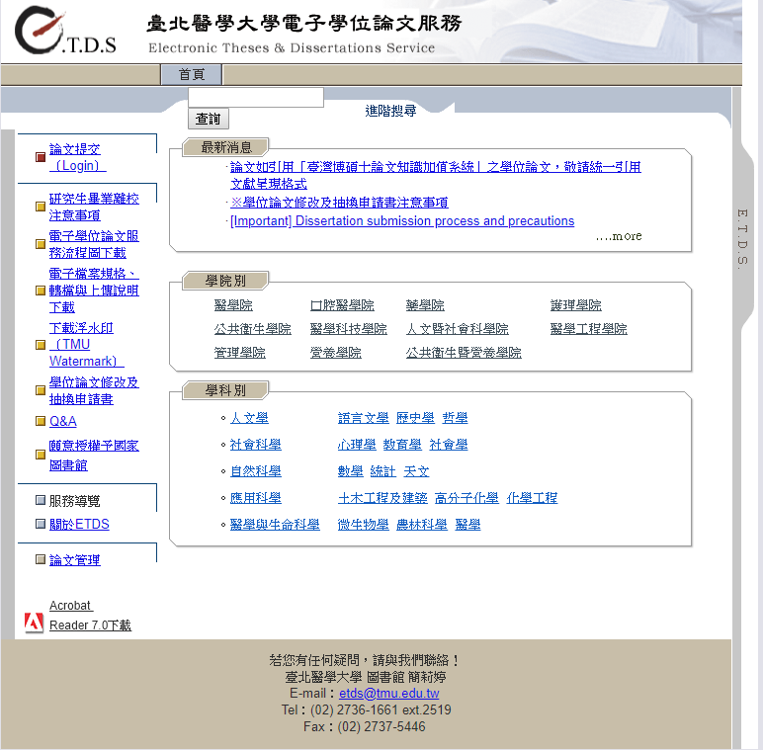

Please contact the library if you have any questions!
Contact: Chien Li-Ting
E-mail：etds@tmu.edu.tw
Tel：(02) 2736-1661 ext.2519
Fax：(02) 2737-5446

VIII. Department Graduation Procedure Application Form

School of Nutrition and Health Sciences Graduation Procedure Application Form
Student Number：
Name：
Address:
Telephone：

Please proceed and sign according to order.

Thesis Advisor
(Thesis completed, lab, keys, books, the materials, equipment and pharmaceuticals checked and turned over).

Department (Chao Yu-Ying, Secretary)
(Submitted one copy of thesis --in black hardcover, and returned books).

Department -Other matters affairs (Chao Yu-Ying, Secretary )
(Copy card expenses)

Department Director (Professor Hsieh Rong-Hong)
□ Submit forms (for master’s program)

Administrative instructor (Professor Chang Jung-Su )

Please complete the Department Graduation Procedure first, then complete University’s Graduation Procedure Application Form

Congratulations on your graduation. After this form has been fully signed, submit it to the administrative instructor for filing.

IX. Graduation Procedure Application Form
Taipei Medical University Graduation Procedure Application Form
Please login the System for the latest version
Fill out by the Student Date of Application: (yyyy) (mm) (dd)
Name  (Print Name) |  | Student ID
Department |  | E-mail
Phone |  | Address | (zip code)  □□□
Authorized | Due to unforeseen circumstances, I am unable to personally participate in the graduation  procedures, and hereby authorize :  (Contact Phone: ____________________ ID number: _______________________ ) to  receive the diploma on my behalf.  Applicant’s signature:  [The agent shall bring his/her own identification documents and those of the applicant  when applying.]

Advisor  (Graduate students Only) | Instructor  (Graduate students Only) | Career Planning and Placement section | Library
 |  | Fill in the graduation questionnaire | Graduate students must upload their thesis files and hand in authorized agreement
Property Management  Section | Cashier Section | International Student  Section  (Except for local students) | Registration Section
 |  | . | Graduate students please confirm  with the department office that  documents of passing degree  examination and softcover theses  have handed in to Registration  Section two days ago.
Notice：
1.Go to the Registration Section to collect your diploma, student ID card needed for verification. If student card lost, please take other valid certificate to complete procedure graduation.
2.Graduate Students please confirm the following things two days ago before the Graduation Procedure:
(1) Upload the theses file to TMU’s Library” Electronic Theses & Dissertation Service” and hand in original authorized agreement signed by students.
(2)Please confirm with the department office that documents of passing degree examination and softcover theses have handed in to Registration Section.

3. Graduation Procedure
(1)Graduate Student: Advisor→ Instructor→ Career Planning and Placement section→ Library → Property Management Section
→ Cashier Section → International Student Section→ Registration Section
(2)Undergraduate: Career Planning and Placement section → Property Management Section → Library → Cashier Section →
International Student Section → Registration Section
＊The Chinese version of this document shall prevail in case of any discrepancy or inconsistency between Chinese version and its English translation.

X. Regulations for Direct Admission into Doctoral Program from Master's Program

When applying, please refer to Division of Registrar website for the latest version of the Regulations.

Taipei Medical University School of Nutrition and Health Sciences Regulations for Direct Admission into Doctoral Program from Master's Program
Formulated and approved by the Academic Affairs Meeting on July 7, 2011

I. The School of Nutrition and Health Sciences (hereinafter referred to as the Department) has formulated this Regulations to enable master's degree students with excellent academic performance and academic research potential to proceed to doctoral programs according to this Regulations.

II. Graduate students in the Department who have not completed their Degree Examination must score an average of 85 points in more than 50% of their required courses, and must have research potential to apply for doctoral direct admission.

III. Applications for doctoral direct admission must include the following documents:
1. A Direct Admission into Doctoral Program application form.
2. Full transcript from the Master's program.
3. Two letters of recommendation from associate professors or above.
4. Three copies each of current thesis progress report and doctoral thesis proposal.
5. Offprints or photocopies of published articles (not required if student has no publication)

IV. Review criteria are as follow:
1. 10% academic achievement and recommendation letters.
2. 20% current thesis progress report.
3. 30% doctoral thesis proposal.
4. 40% interview performance.

V. Doctoral direct admission in the Department is limited to 40% of the doctoral program enrollment quota approved by the Ministry of Education for the current academic year. If the approved enrollment quota is less than five, then the maximum is two students. The number of doctoral direct admission is decided by the Department Affairs Meeting and College Affairs Meetings each January and submitted to the Academic Affairs Office for review.

VI. The Department Admissions Committee shall convene a review meeting and arrange for interviews within two weeks after accepting applications for doctoral direct admission. The review outcome will be reported to the Department Affairs Meeting in May for approval.

VII. The Department will submit minutes of the Department Affairs Meeting, list of qualified graduate students and other relevant documents to the Dean of College, Dean of Academic Affairs and the University President for approval before the beginning of classes in each semester.

VIII. From the time of their admission acceptance, the graduation requirements for doctoral direct admission students in the Department shall be handled according to the Department's Doctoral Student Graduation Regulations.

IX. Doctoral students admitted directly from master's programs who withdraw from the doctoral program or who fail to pass their doctoral degree candidate examination may return to their master's program upon review and approval by the Department Affairs Meeting and the University President. In accordance with regulations, the abovementioned graduate students shall complete their required master's courses, submit their thesis, and pass the Degree Examination by the Examination Committee to receive their Master's degree. The duration of doctoral studies will not be counted toward the maximum duration allowed for the master's program.

X. Doctoral students admitted directly from master's programs who have been approved for doctoral degree candidacy but fail to pass their doctoral examination by the end of the program duration may be awarded master's degree if their doctoral thesis is approved by the Doctoral Degree Examination Committee and they have fulfilled the master's degree requirements.

XI. Other matters not included in this Regulations shall be handled in accordance with relevant provisions of the Ministry of Education and the University.

XII. These Regulations are issued and implemented upon review and approval by the Department Affairs Meeting, the College Affairs Meeting and the Academic Affairs Meeting; amendment to these Procedures is subject to the same process.

XI. Scholarships, Lab Funds and Other Items

1. Scholarships
Please refer to Office of Global Engagement: https://oge.tmu.edu.tw/

2. Other Reminders
To facilitate and speed up communication, emails will be used as the primary means of contact. Students should check their mail regularly to avoid missing messages.

Attachment: Master's Thesis Format

I. General Format
1. The dissertation comprises three main parts: the preliminaries, the main text and the reference.
2. The dissertation must be written in Chinese (except for the English abstract), in horizontal alignment. Font size should not be too large or too small. Font sizes of 14 for titles and 12 for text are recommended.
3. Dissertation should be printed on A4 paper, about 210x297 mm, with letterpress or mimeograph printing on single side.
4. Text, table, figure and photo layout should be based on the following margin specifications:
Top: 2.5 cm; Right: 2.5 cm; Bottom: 2.5 cm; Left: 3.0 cm
The page number may be outside this range, but with no less than 1.8 cm margin (see Item 1 Rule 1 in IV. Rules for Main Text).
5. Dissertation must be double spaced. However, footnotes, references, table of content and appendices may be single spaced.
6. The Chinese and English abstracts should be no more than one page.
7. Page number layout: Layout for page number must be consistent. Arrange page numbers according to the following rules:
(1) Inside cover: Pagination not required.
(2) Examination Committee approval letter: Pagination not required.
(3) Authorization letters: Pagination not required
(4) Chinese abstract: Paged as I.
(5) English abstract: Paged as II.
(6) Other preliminaries are paged in order according to Roman numerals (III, IV, V, VI.....). The preliminary section may include acknowledgements, table of content, list of tables and list of figures.
(7) Pagination for the main text is ordered in Arabic numerals, starting with page number "1".
II. Cover Page
1. Specification: Refer to the attached example.
2. Book spine: Refer to the attached example.
3. Cover color: Black for Department hardcover copy. Customize color for other hardcover and paperback copies.
4. Word color: Hardcover - stamped gold; paperback - black.
III. Content Order
1. First page: Taipei Medical University Graduate Thesis Certification.
2. Second page: Taipei Medical University / National Central Library Application Form for Delaying public Access to Thesis /Dissertations
3. Third page: Chinese abstract.
4. Fourth page: English abstract.
5. Fifth page: Dedication Page(Optional).
6. Sixth 6: Acknowledgements.
7. Seventh Page: Table of Contents (refer to the attached example).
8. Eighth 8: List of figures (refer to the attached example).
9. Ninth Page: List of tables.
10. Main text.

IV. Rules for Main Text
1. Page number is in Arabic numerals, centered at 1.8 cm from the bottom of the page or at 1.8 cm from the top right corner.
2. Each chapter must begin with a new page.
3. Experimental outcome tables and figures should be listed on a separate page and not mixed with text content. Each page should contain no more than two figures or tables. Figures and tables may be presented vertically or horizontally.
4. The title of tables should be placed above the tables, and the description place below the table.Figure title and description should be placed below the figure. Footnotes may be in either Chinese or English.
5. If experimental outcome includes photos, the photos must be printed on glossy photo paper and pasted within specified range. Photos must be originals. Photocopies are prohibited.
6. For reference in Chinese, refer to the regulations of Nutritional Sciences Journal. For reference in English, refer to the regulations of Journal of Nutrition:

V. Copies of dissertation to be submitted
1. Hardcover (black) Copy: to the Department.
2. Paperback Copy: One copy to the Academic Affairs Office (for submission to the National Central Library).

【Example】

Taipei Medical University
Master Program in School of Nutrition and Health Sciences

Master Thesis

Thesis English Title

Advisor：X X X (Dr. or professor, etc., Name in English)
Co-advisor： X X X (Dr. or professor, etc., Name in English)

Graduate Student：X X X (Name in English)

June 201X

Taipei Medical University Master Program in School of Nutrition and Health Sciences
Master Thesis Title Name XXX 201X

Content
Page Number
Chinese Abstract…………………………………………………………………………………………….………………. I
English Abstract………………………………………………………………………………………………………………. II
Acknowledgements…………………………………………………………………………………………………………. III
Table of Content…………………………………………………………………. ……………………………………………. IV
List of Tables……………………………………………….....………………………………………………………………. V
List of Figures…………………………………………………………………………………………………………………. VI
Chapter One Introduction
Section 1 ＸＸＸＸＸＸ………………………………………………………………………………. XX
Section 2 ＸＸＸＸＸＸ…………………………………………………………………………. XX
Chapter Two Literature Review
Section 1 ＸＸＸＸＸＸ………………………………………………………………………. XX
Section 2 ＸＸＸＸＸＸ…………………………………………………………………………. XX
Chapter Three Materials and Method (or Method and Procedure)
Section 1 ＸＸＸＸＸＸ………………………………………………...…………………………. XX
Section 2 ＸＸＸＸＸＸ…………………………………………………………………………. XX
Chapter Four Results
Section 1 ＸＸＸＸＸＸ………………………………………………………………………. XX
Chapter Five Discussion
Section 1 ＸＸＸＸＸＸ…………………………………………………………………………………. XX
Section 2 ＸＸＸＸＸＸ…………………………………………………………………………. XX
Chapter Six Conclusions and Recommendations
Section 1 ＸＸＸＸＸＸ…………………………………………………………………………. XX
References……………………………………………………. …………………………………….........…………………… XX
Appendix 1..………………………………………………………………………………………...……………………….. XX
Appendix 2 …….…………………………………………………... ……………………………………....…………………. XX

Note: The following specifications may be used if the title consists of several separate parts.

Content

Chapter One Literature Review
Chapter Two Title
1. Introduction
2. Materials and Method (or Method and Procedure)
3. Results
4. Discussion

Chapter Three Title
1. Introduction
2. Materials and Method (or Method and Procedure)
3. Results
4. Discussion

Chapter Four Title
1. Introduction
2. Materials and Method (or Method and Procedure)
3. Results
4. Discussion

Chapter Five Conclusions
References
Appendix 1
Appendix 2

List of Figures
Page Number
Figure 1…………………………………………………………………………………………………………………… 8
Figure 2…………………………………………………………………………………………………………………… 10
Figure 3…………………………………………………………………………………………………………………… 14
Figure 4…………………………………………………………………………………………………………………… 16
Figure 5…………………………………………………………………………………………………………………… 25
Figure 6…………………………………………………………………………………………………………………… 26
Figure 7…………………………………………………………………………………………………………………… 28
Figure 8…………………………………………………………………………………………………………………… 29
Figure 9…………………………………………………………………………………………………………………… 30
Figure 10………………………………………………………………………………………………………………. 31
(Same for List of Tables)

